**HOTEL BOOKING ANALYSIS**

**1.Knowing the Data**

**Importing Required Libraries**

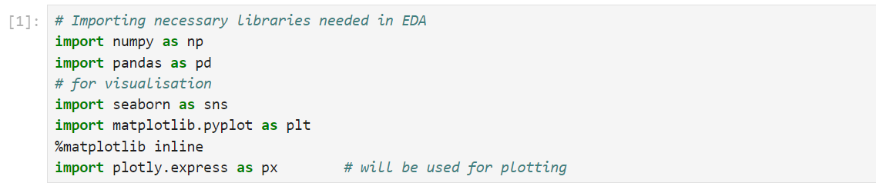

**Dataset Loading**

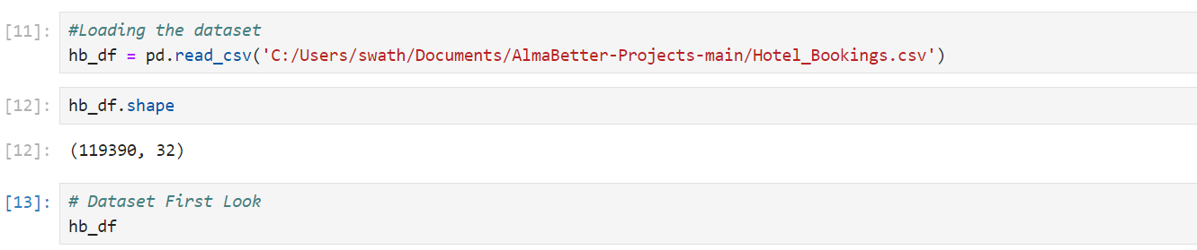

### Dataset First View

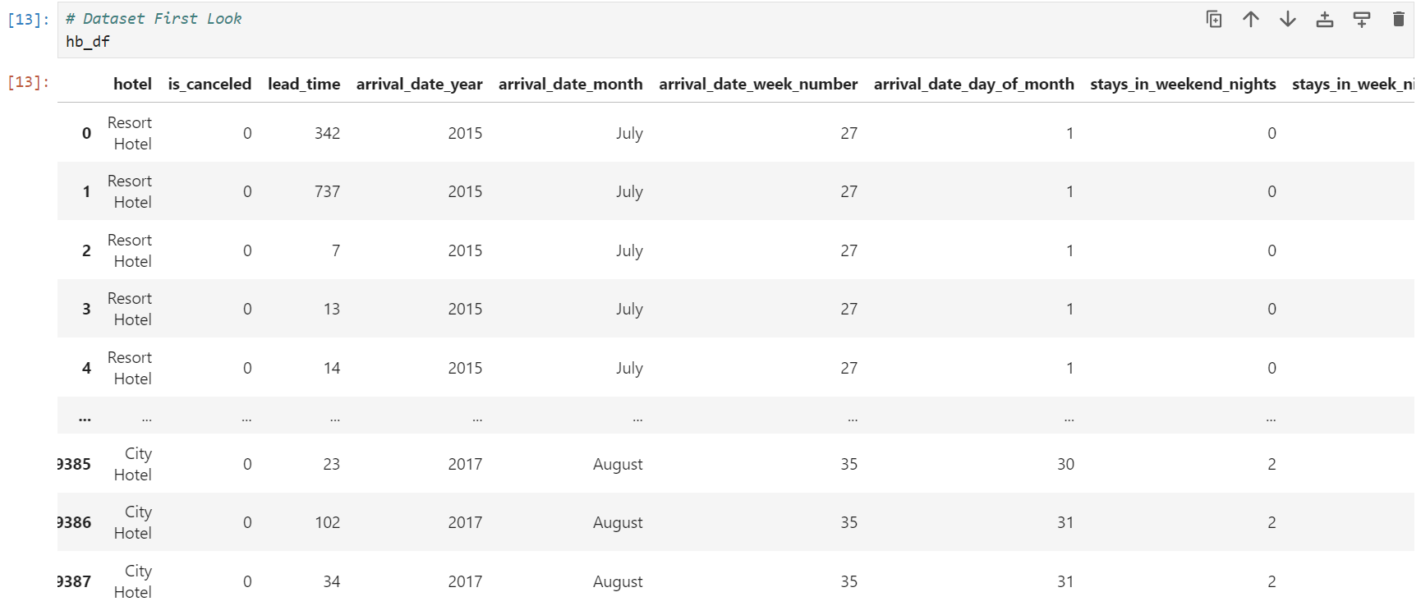

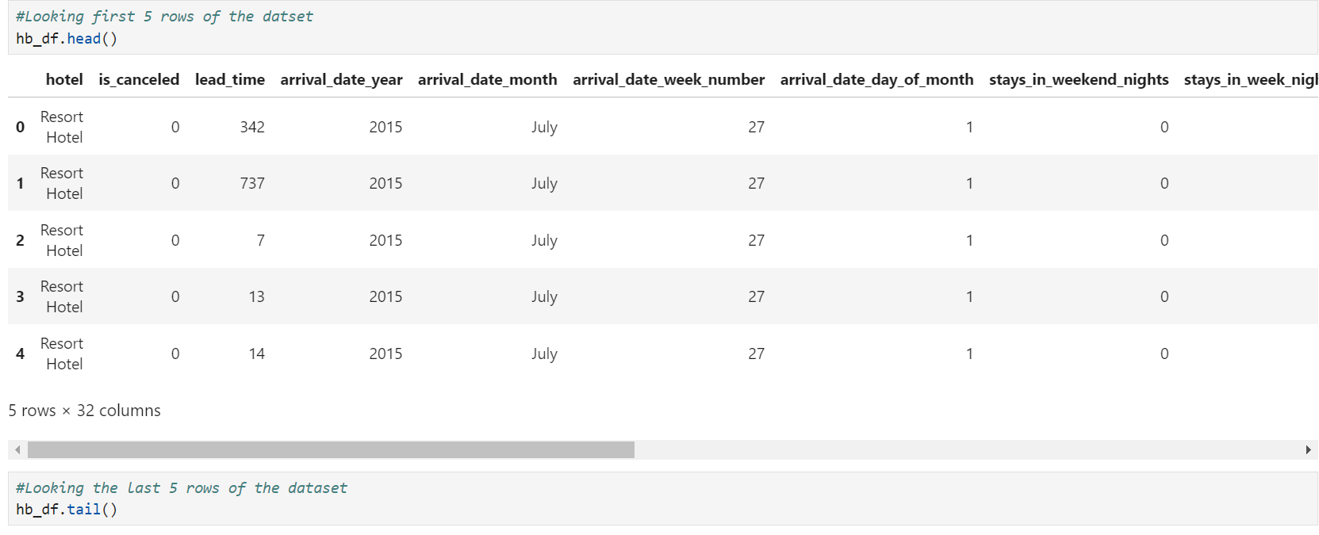

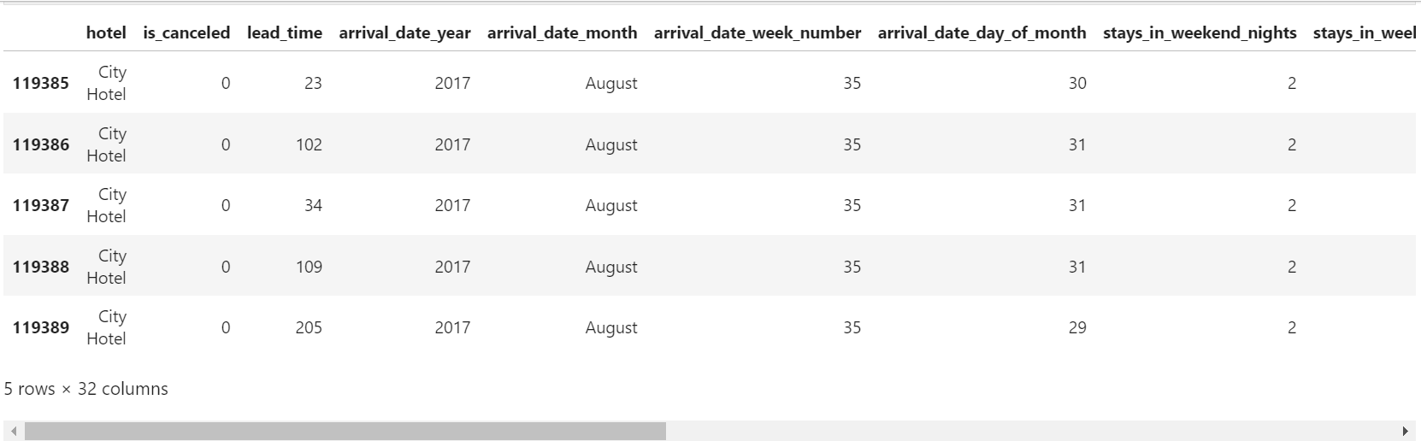

### Dataset Rows & Columns count

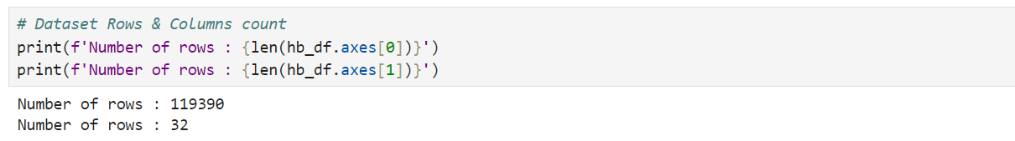

### Dataset Information

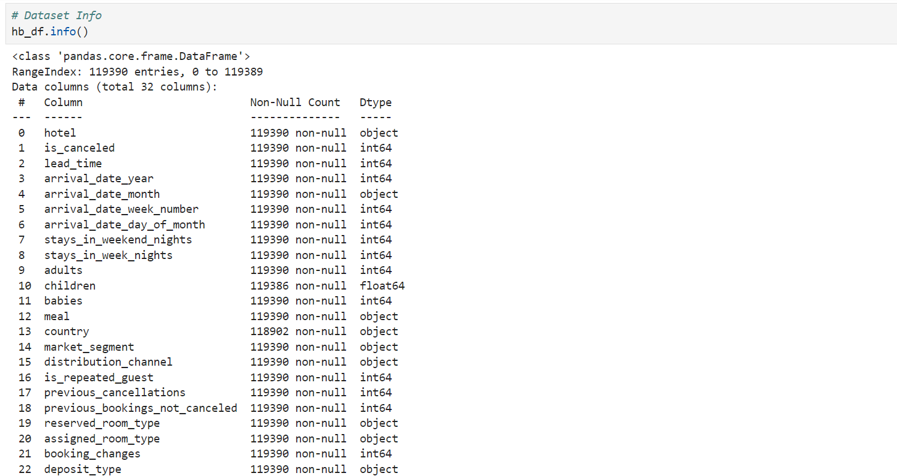

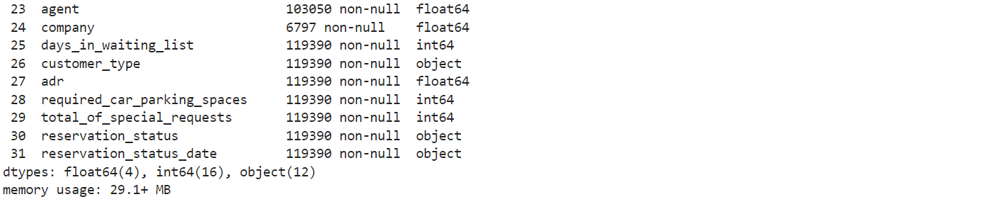

#### **Duplicate Values**

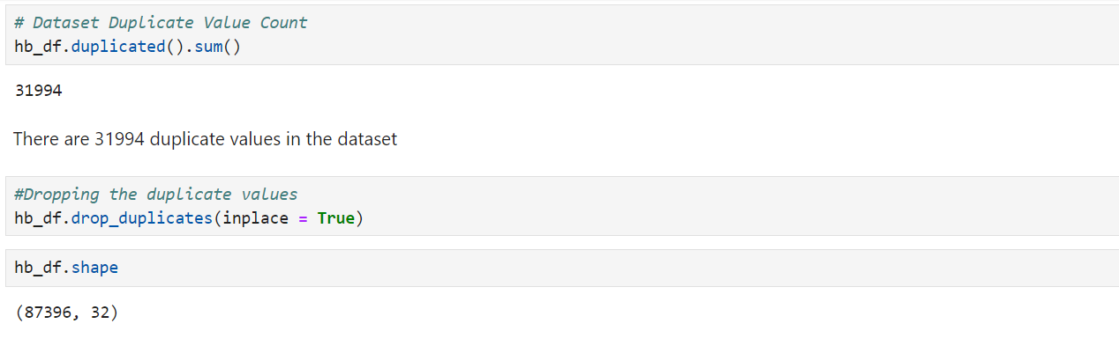

#### **Missing Values/Null Values**

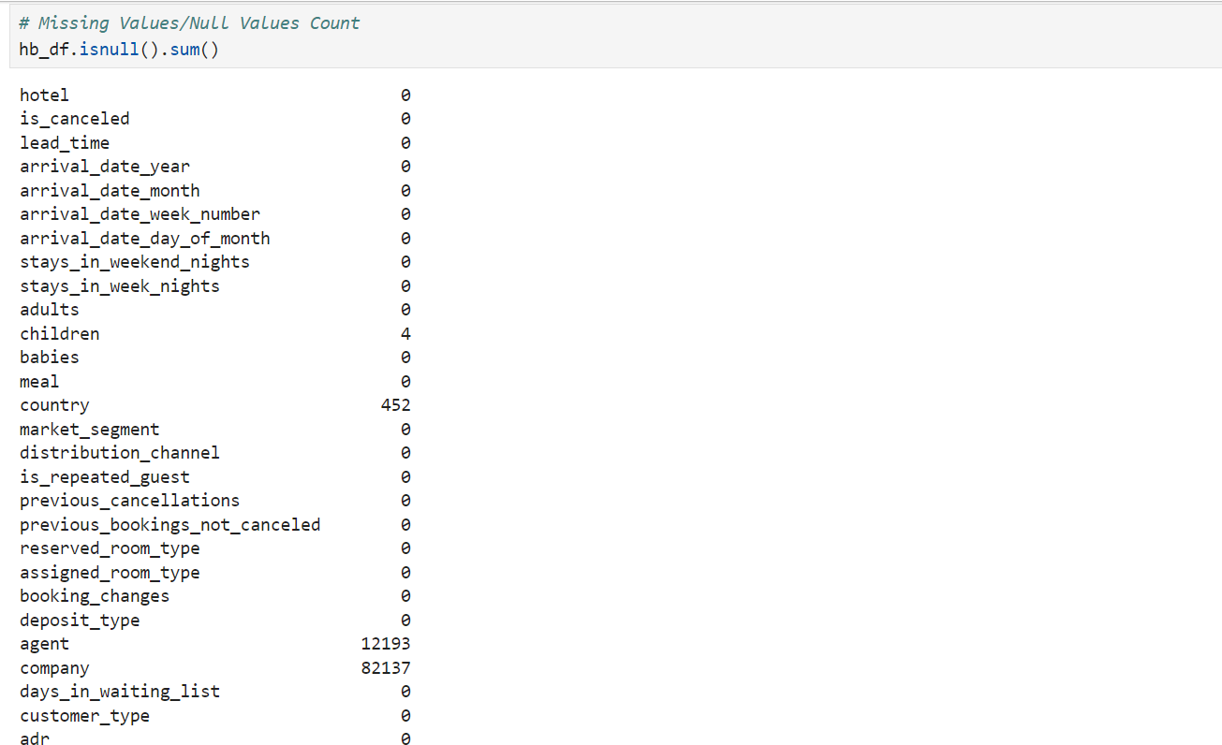

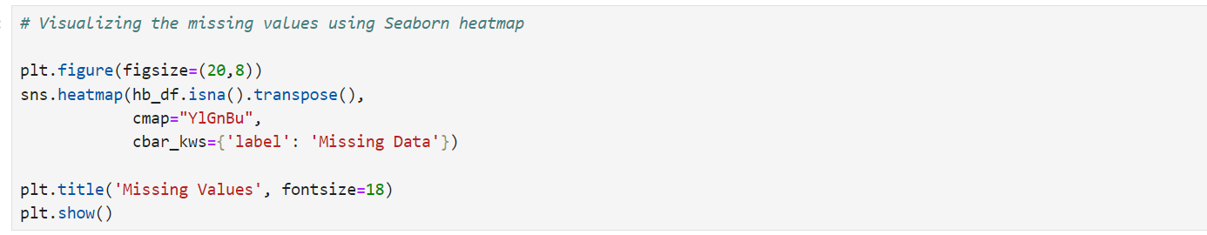

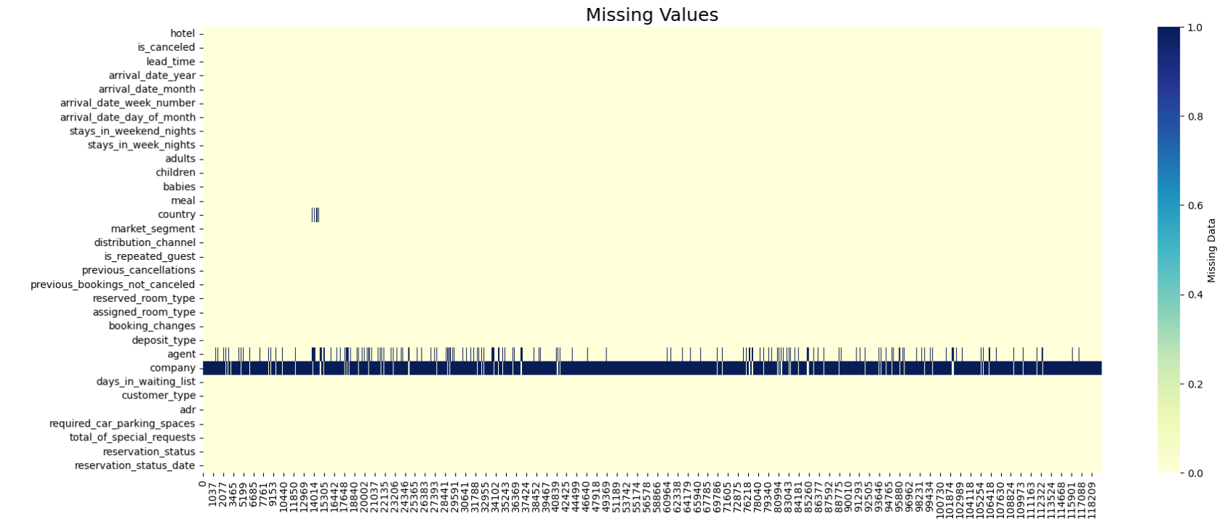

**2.Understanding The Variables**

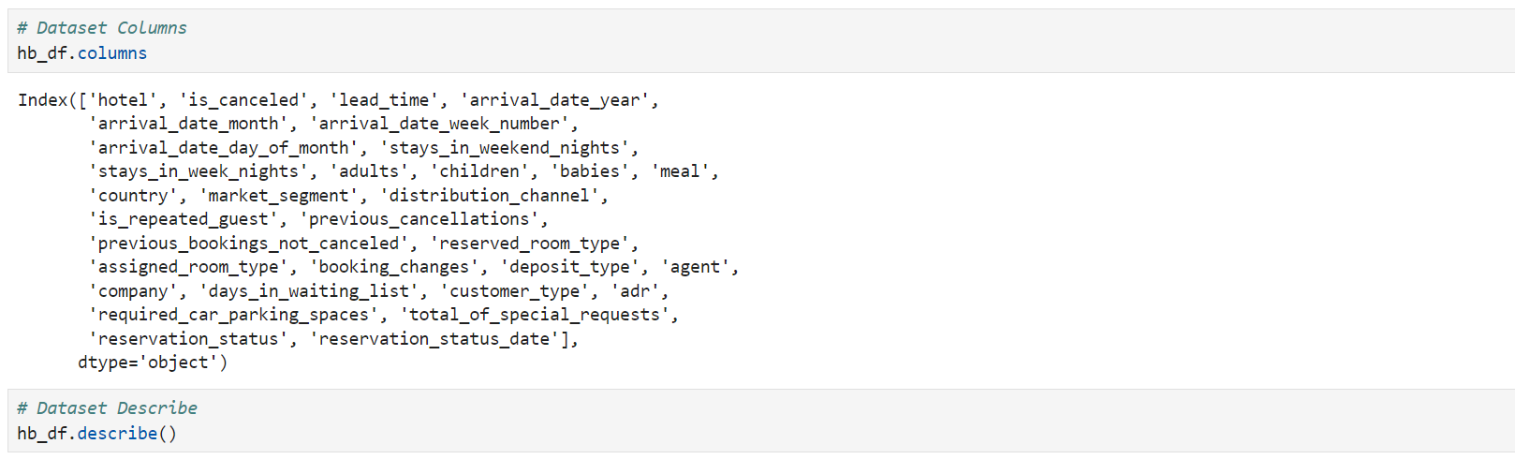

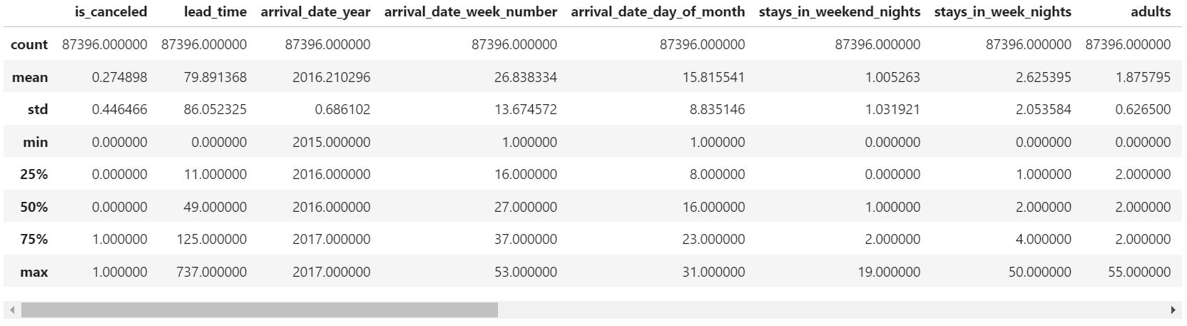

### Variables Description

1. **Hotel :** (Resort Hotel or City Hotel)
2. **is_canceled**: Value indicating if the booking was canceled (1) or not (0)
3. **lead_time :** * Number of days that elapsed between the entering date of the booking into the PMS and the arrival date*
4. **arrival_date_year :** Year of arrival date
5. **arrival_date_month :** Month of arrival date
6. **arrival_date_week_number :** Week number of year for arrival date
7. **arrival_date_day_of_month :** Day of arrival date
8. **stays_in_weekend_nights :** Number of weekend nights (Saturday or Sunday) the guest stayed or booked to stay at the hotel
9. **stays_in_week_nights :** Number of week nights (Monday to Friday) the guest stayed or booked to stay at the hotel
10. **adults :** Number of adults
11. **children :** Number of children
12. **babies :** Number of babies
13. **meal :** Type of meal booked. Categories are presented in standard hospitality meal packages
14. **country :** Country of origin.` market_segment : Market segment designation. In categories, the term “TA” means “Travel Agents” and “TO” means “Tour Operators”
15. **distribution_channel :** Booking distribution channel. The term “TA” means “Travel Agents” and “TO” means “Tour Operators”
16. **is_repeated_guest :** Value indicating if the booking name was from a repeated guest (1) or not (0)
17. **previous_cancellations :** Number of previous bookings that were cancelled by the customer prior to the current booking
18. **previous_bookings_not_canceled :** Number of previous bookings not cancelled by the customer prior to the current booking
19. **reserved_room_type :** Code of room type reserved. Code is presented instead of designation for anonymity reasons.
20. **assigned_room_type :** Code for the type of room assigned to the booking.
21. **booking_changes :** Number of changes/amendments made to the booking from the moment the booking was entered on the PMS until the moment of check-in or cancellation
22. **deposit_type :** Indication on if the customer made a deposit to guarantee the booking.
23. **agent :** ID of the travel agency that made the booking
24. **company :** ID of the company/entity that made the booking or responsible for paying the booking.
25. **days_in_waiting_list :** Number of days the booking was in the waiting list before it was confirmed to the customer
26. **customer_type :** Type of booking, assuming one of four categories
27. **adr :** Average Daily Rate as defined by dividing the sum of all lodging transactions by the total number of staying nights
28. **required_car_parking_spaces :** Number of car parking spaces required by the customer
29. **total_of_special_requests :** Number of special requests made by the customer (e.g. twin bed or high floor)
30. **reservation_status :** Reservation last status, assuming one of three categories
31. **Canceled –** booking was canceled by the customer **Check-Out –** customer has checked in but already departed **No-Show –** customer did not check-in and did inform the hotel of the reason why **reservation_status_date -** Date at which the last status was set